Minutes – Board of Directors Meeting
Nepean Minor Hockey Association
February 27, 2025
In attendance: Ingrid Meza-McDonald, Shelley Perras, Scott Dawson, Jennifer Emery, Jessica Kingsbury, Jeff Pollard, Janice Vanderwel, James Pitruniak
Regrets: Alan Wilson (Away)

# | Time Allotted | Item | Lead
1 | 5 mins  6:00-6:05PM | Approve Agenda and Previous Minutes | Ingrid
2 | 15 mins  6:05-6:20 | Spring Tryout Fees  Motion: Approve fees for Spring 2025  Motion $250 and $125  Moved James  Seconded Scott  Votes: 4 yes, 2 No (Jeff Opposed) | Ingrid
3 | 15 mins  6:20-6:35 | VP Finance Update  Competitive Surcharge  - Completed and shared  First draft of 2025/2026 Budget and Registration Fee Update  - Timeli  - Motions: Early Bird Discount, Family Prici | James
4 | 60 mins  6:35-7:35PM | Review and Approve New Budget Items  - Timekeeper Pay Adjustment  - Review proposal submitted by Jay and Jeff  Motion: Scott  Second: Shelley  Approved.  - EDI Speaker, $15K/every second year  Motion: Shelley  Second: Jeff  Approved.  - Socks  - For house league –  Motion: Jeff  Second:  Approved.  - Pinnies  - $5,000-  Motion: Jen  Second: Jeff  Approved.  - Tryout Jerseys  - U21 Program  - House Ice Scheduler  - Goalie Development  See Appendix 2 below | All
5 | 10 minutes  7:35-7:45PM | Proposal for End of Year Gift  Proposed: From Gadar - personalized screen-printed pucks individualized for each player (1859 unique pucks) - Total cost: $11,085.30 ($5.96 per puck) | Jessica
6 | 7:45PM | Meeting Adjournment | All

Appendix 1 – Consider the following two options. The carryover fee is not an option for the 2025-26 season.

Summary:
  - The expenses are fixed for both tryouts and we cannot get around these expenses.
  - All profits from competitive tryouts are invested back into the competitive program, including goalie development proposal, offset surcharge etc.
  - In order to accomplish a cost recovery model, we cannot go lower than $234.65 in the Spring and $117.63 in the Fall, this is based 700 transactions combined.
  - It's important to note that tryout fees have not been increased in four years.
  - Other associations are at $300-$250 AA and B $200-$150
  - Approx. 125 players will be participating in U18 tryouts in the Fall, these fees should be reflective of AA and B tryouts set out. These fees will be determined once we confirm AA fees for spring.

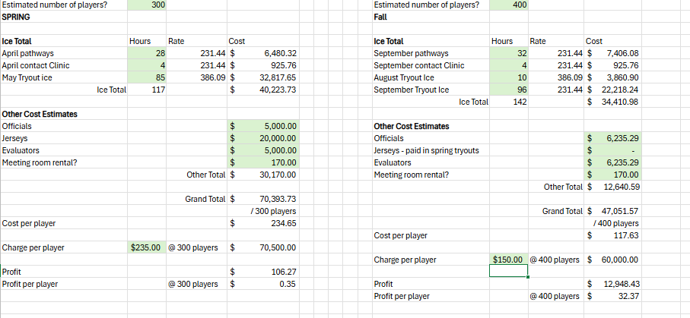

APPENDIX 2 (Previous Meeting)

NMHOP- Ingrid
1. The Nepean Minor Hockey Officiating Program (NMHOP) and the Nepean Minor Hockey Association (NMHA), the parties, have an agreement to the funding of $3500.00 towards the referee and timekeeper’s development program for the 2025-26 hockey season.
a. Clause regarding third party booking must be approved by NMHA, and must adhere to policies governed by HEO and Hockey Canada
2. Increase in Timekeepers Fees: (NMHOP)
a. This year, for the first time, we achieved an over 85% retention level for timekeepers. Historically, our retention rate has been only 30%.
b. The consistency and experience of our timekeepers have significantly improved the efficiency and quality of our games.
c. By maintaining this high retention rate, we can continue to build on this success and further enhance our program.
3. Recommendations:
a. Accountant brought forward we do not deduct any taxes from these fees, we need to be cautious of increases
b. No changes to AA/A,
c. Increase Reb B and House where there are gaps, increase by $1.00, (*) not $2
d. Except for U12/13 Rep B & House ** 60min increase by $2.00
e. U21 no changes required

Motions:
Jeff-
1. Competitive AK style socks for everyone, house and competitive.
a. Reasoning: This would cut down on tracking/stocking two separate types of socks.
b. Discussion: Increase of $5 to registration for cost recovery. All current wool socks will be issued to U21 until inventory is used up as most of our inventory is the 36". No increase to U21 registration.
Motion:
Seconded:
Approved

2. Tryout jerseys for all, house and competitive.
a. Reasoning: This would reduce the administrative burden for convenors/volunteers with pinnies and tracking different numbers for each tryout. Also, the tracking of return of pinnies for each tryout.
b. Discussion: Increase registration cost of jersey for house tryout, if player already has a numbered jersey, that can be used and also what is the increased workload of handing out/ordering tryout jerseys.
3. Ordering different colour tryout jerseys then red and white.
a. Reasoning: With three lines per team, coaches normally have a red, white and black line so if we have a different tryout colour this year, say yellow and blue, then the third line could be one of those colours. Right now, some parents have had to buy a black jersey.
b. Discussion: How possible is it to buy different colour options?
4. Paying Non-Parent coaches in Competitive.
a. Reasoning: By paying non-parent coaches, the association could attract more interest.
b. Discussion: Cost would be split between team and association (50/50) and executive agree upon how much to pay non-parent coach if this motion is agreed upon.
5. Something completely out of the box but please think about this one. Hire an in-house Goalie Development coach like the Technical Director.
a. Reasoning: I believe that as an association, our goalies are not at the level they should be, we are not represented well at the AAA level, there are a number of imports for Myers or Kanata goalies, I can get this exact information and even within our own association, we have two goalie imports. Our own goalie coach would have to be on-ice with teams and coach goalies. For example, they would have to practice 12 hours per week and pick teams.
b. Discussion: Responsibilities, House and Competitive, Cost, etc.

Jen-
House Budget needs for 2025-2026:
1. The purchase of new pennies for U11, U13, U15 and U18. (Quote Pending)
a. Requirement 2 sets of 50 pinnies per division
b. Different colours per division to avoid mixing and for ease of tracking.
2. Requesting $500 to be allocated to house sort outs for the purchase of administration supplies and prepare kits for each division convenor. (This amount will be in addition to the $500
a. Pens
b. Whiteout
c. Fine point sharpies
d. Clip boards
e. Pocket doutangs
3. U21 there are two options – to put forward:
a. Increase registration costs to cover U21 tournament entry, this is minimal amount and additional $50 dollars per player. Ask $100 dollars for team fees, to cover the cost of jersey deposit and any additional team expenses.
b. Leave registration the same and each player will have to pay $150 dollars’ worth of team fees.
4. For U7 – Look at purchasing equipment that is meant for hockey training, easy to store and move from storage locations. Asking $1500 -$2500
a. Recently noticed the bulk of some of the items, some more compact items might help to alleviate the need for large storage areas
b. Some items are currently homemade and may pose safety hazard
c. New hockey related training items are foldable, stackable and compact
d. City is reluctant to have our U7 items stored in the facility. Goal – Compact storage and player safety.
5. Motion to Hire Goalie Trainer: (Comp teams still required to allocate goalie training)
- · Purpose to focus on development of both the competitive and house goalies
- · Assist in conditioning camps for both comp and house goalies
- · Run the comp goalie sort out sessions, as well as the house goalie sessions and assist in the evaluations of both
- · Run bi-weekly goalie sessions, one-week comp, the other house
- · Assist both comp and house coaches with drills and skills to work on for the age and technical ability of players
- · SHIFT sessions will still be provided to house players – 3 sessions each
- · Comp teams will receive up to between 4-8 individual sessions with goalie mentor. ***Open to discussion on options and how to implement, think this is a set salary, with some hourly rate additions for any extras requested. ***
Option 2 Goalie Training:
· House receives 3 SHIFT sessions, as well as bi-weekly goalie sessions by trainer brought in to NMHA ice.
· Comp teams are provided $700 dollars per goalie for goalie specific training from association. Teams must supplement, these funds from team fees, minimum of $1400-dollar allocation.
Specialized Goalie Trainer to run:
· Comp tryouts sessions and evaluation, working in collaboration with Technical Director
· House Sort outs sessions and evaluation
6. Motion: To propose providing House and Comp teams set allocation from registration to help alleviate the burden of fundraising and lessen the need to increase team fees.
· Allocation to house from registration fee $50
· Allocation to comp teams from registration $100

Ingrid-
- Motion to review one (1) or two (2) paid ice schedulers for the house programming, to reduce the volume work on our convenors.
  - U9- U13 House ice scheduler 1- Honorarium of $4000
  - U15-U18 House ice scheduler 2 - Honorarium of $4000
Rationale
  - Feedback received from convenors, there is a lot more hours required with the ice scheduling
  - Two returning convenors, we must recruit for U7, U9, U11, U13, U18
  - We currently have a comp ice scheduler that works with our Master scheduler, facilitates teams and managers to reschedule as needed and allocate practices
    - Comp honorarium is $5,900
Ingrid/ Scott-
- Motion to review an honorarium for the tournament coordinator of $2500 to run and manage our House Tournaments for the 2025-26 season
  - Cost recovery from tournament profits
  - Allocate a set tournament “player of the game prizing” amount for the tournament coordinator to manage
  - Current range on spend is $100- $1000
  - Allow the tournament coordinator to come back with proposal, after seeking quotes etc.

